Supporting Frontline Health Workers through the Use of a Mobile Collaboration Tool

Jane Li1, Leila Alem2, Weidong Huang3

1CSIRO Digital Productivity Flagship,

PO Box 76, Epping NSW 1710, Australia

[Jane Li@csiro.au](mailto:Jane%20Li@csiro.au)

2University of Technology, Sydney, Australia

Leila.Alem@uts.edu.au

3University of Tasmania, Australia

Tony.Huang@utas.edu.au

**Abstract.** This paper presents our work in exploring the design of a mobile collaboration tool to support frontline health workers who deliver healthcare services at local communities and patients’ homes. Our design addresses their collaboration needs when they discuss patient cases with remote clinicians during the home visits. The tool is tablet-based and supports real-time communication and information sharing between health workers and clinicians and also asynchronous information exchange between them through the recording of rich media annotations. We present preliminary results from a pilot study examining the usability of the tool.

1. Introduction

Frontline health workers are those directly providing services to patients in area where they are most needed, particularly in remote and rural areas. Due to the shortage of skilled clinicians (e.g. medical specialist, general practitioner, specialist nurse), frontline health workers play a pivotal role in assisting the delivery of healthcare services at the local communities and patients homes. They are trained to manage patients’ chronic conditions, common infections and other basic health needs. They also help identify conditions which require higher levels of care and provide a link to other healthcare service providers who work with them as a team for the care of patients.

Empowering frontline health workers and providing them with means to access clinical expertise when needed are important for them to deliver services to their patients. We have engaged with a group of clinicians and health workers and identified two collaboration needs. Frontline health workers may need to discuss patient cases in real time with remote clinicians to make decisions regarding the care of the patients during the home visits. As clinicians are not necessarily available, frontline health workers may also need to engage with clinicians by using asynchronous communication - health workers capture and save information collected during the home visits and share it with clinicians who review it at convenient time for assessment offline.

We have explored the design of a mobile collaboration tool. Our design work has been informed by the two collaboration needs of frontline health workers.

This work is a preliminary contribution to the research in the field of telehealth which focuses on remote collaboration in healthcare. There are two traditional modes of collaboration in telehealth. One is real-time telehealth and the other is stored-and-forward or asynchronous telehealth which has been commonly used when real-time collaboration is not practical. Recently studies have suggested that a “hybrid” approach which integrates real-time and asynchronous telehealth fits well with clinicians’ work flow and improves the efficiency of their practices [1, 2].

Our design has been inspired by the recent development in social media communication and cross time zone collaboration in which the boundary between synchronous and asynchronous interactions is blurred [3, 4]. Researchers have explored the design of rich media contents - combining the recordings of audio and video of interactions (e.g. annotation) over artefacts, as proxies for asynchronous communication [3, 4]. Annotation over video and still images provides rich support for real time collaboration [5, 6]. Our work extends the work of [3, 4] by incorporating the feature of recording annotation over video content.

Real-time telehealth relies on audio-video communication and sharing a range of medical information to support healthcare professionals to discuss patient diagnoses and treatment plans. Mobile and tablet devices have been increasingly used in telehealth [7]. One of our attentions is directed to how to appropriately integrate and configure audio-video communication space with information sharing space in mobile tablet devices to address the complexity of interactions in telehealth.

In this paper we first outline the technical design of the collaboration tool. We then present preliminary results of a pilot study that examined the usability of tool. We will finish with a discussion of potential future work.

1. Design

In this section we will briefly introduce the design of the mobile collaboration tool (ReColl). Hand-held table device is used as hardware interface for ReColl as it is portable for health workers to carry it around. The tablet used for the current version of the prototype of ReColl is iPad with 9.7 inch display. Same interface is facilitated at the clinician side and it can be adapted to other types of platforms.

ReColl supports the following *real-time* interactions between health workers and remote clinicians:

* Video conferencing by using the built-in cameras, microphone and speaker
* Using cameras to show patient details (e.g. skin color, wound) to the clinicians
* Sharing medical information, including patient records (e.g. medical images) in medical record systems, cloud-based information systems (e.g. patient monitoring data) and patient images captured by the iPad cameras
* Annotating over shared information

ReColl also enables the *asynchronous* information sharing to be used when the case is not urgent and when clinicians are not available for real-time interactions. The asynchronous mode allows the creation of a rich media annotation composed of annotated images and videos to be shared for asynchronous discussion and information exchange. When a health worker annotates a patient record or an image of a patient, a short video with the audio of the health worker can be captured by the iPad and recorded together with the patient record or image and annotations (Fig.1). This rich media annotation is then sent to a clinician who can review it at a convenient time and may respond with their own annotations of the content.

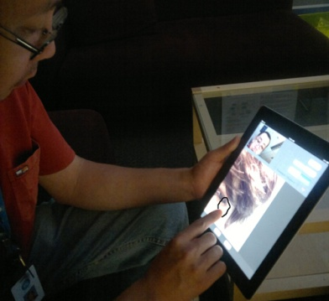

**Fig. .** Recording a rich media annotation

1. User Study

A pilot study has been conducted in our laboratory to test the functionality and usability of ReColl. The study was conducted using an initial prototype and has been part of the on-going iterative design processes. While our future work includes testing these tools in a real world setting, the focus of the study has been to improve the design by observing how users communicate and interact in collaborative tasks designed to mimic the typical activities of information sharing in telehealth.

We tested the use of the rich media recording for asynchronous communication and the use of real-time interaction functionalities. 10 university students, 2 software engineers and 2 researchers participated in the study. There were 10 males and 2 females. Each session included two randomly assigned participants who were located in two separated rooms. Each pair of participants worked together to complete two collaborative negotiation tasks. Participants filled in a questionnaire at the end of the session and this was followed by a debrief session between the participants and us.

In each session, participants were required to first review a pre-recorded and annotated video explaining the problem to be solved, in this case the need to plan a picnic party in a park. The pre-recorded message consisted of the video recording of the instructor explaining the scenario, a map image of the park and a video recording of his annotations on the map as he explaining the constraints and context of the picnic. After this the pair engaged in two real time negotiation tasks. One was to agree on a location of the party. Each participant was allowed to annotate the map of the park when putting forward their individual suggestions. The second task was to create games to entertain the people attending the party. Each participant had a number of physical objects they could draw on to create a game. The objects were put on a table in front of them. Participants were allowed to use the rear camera of their iPads to show the objects they had, or take still images of these objects, annotate them and share them with their partners. Our aim was to understand how users perceived the rich media annotations in the asynchronous mode when receiving the instructions (Fig. 2) and how the real time interaction functionalities, including annotation, were used to support the collaboration.

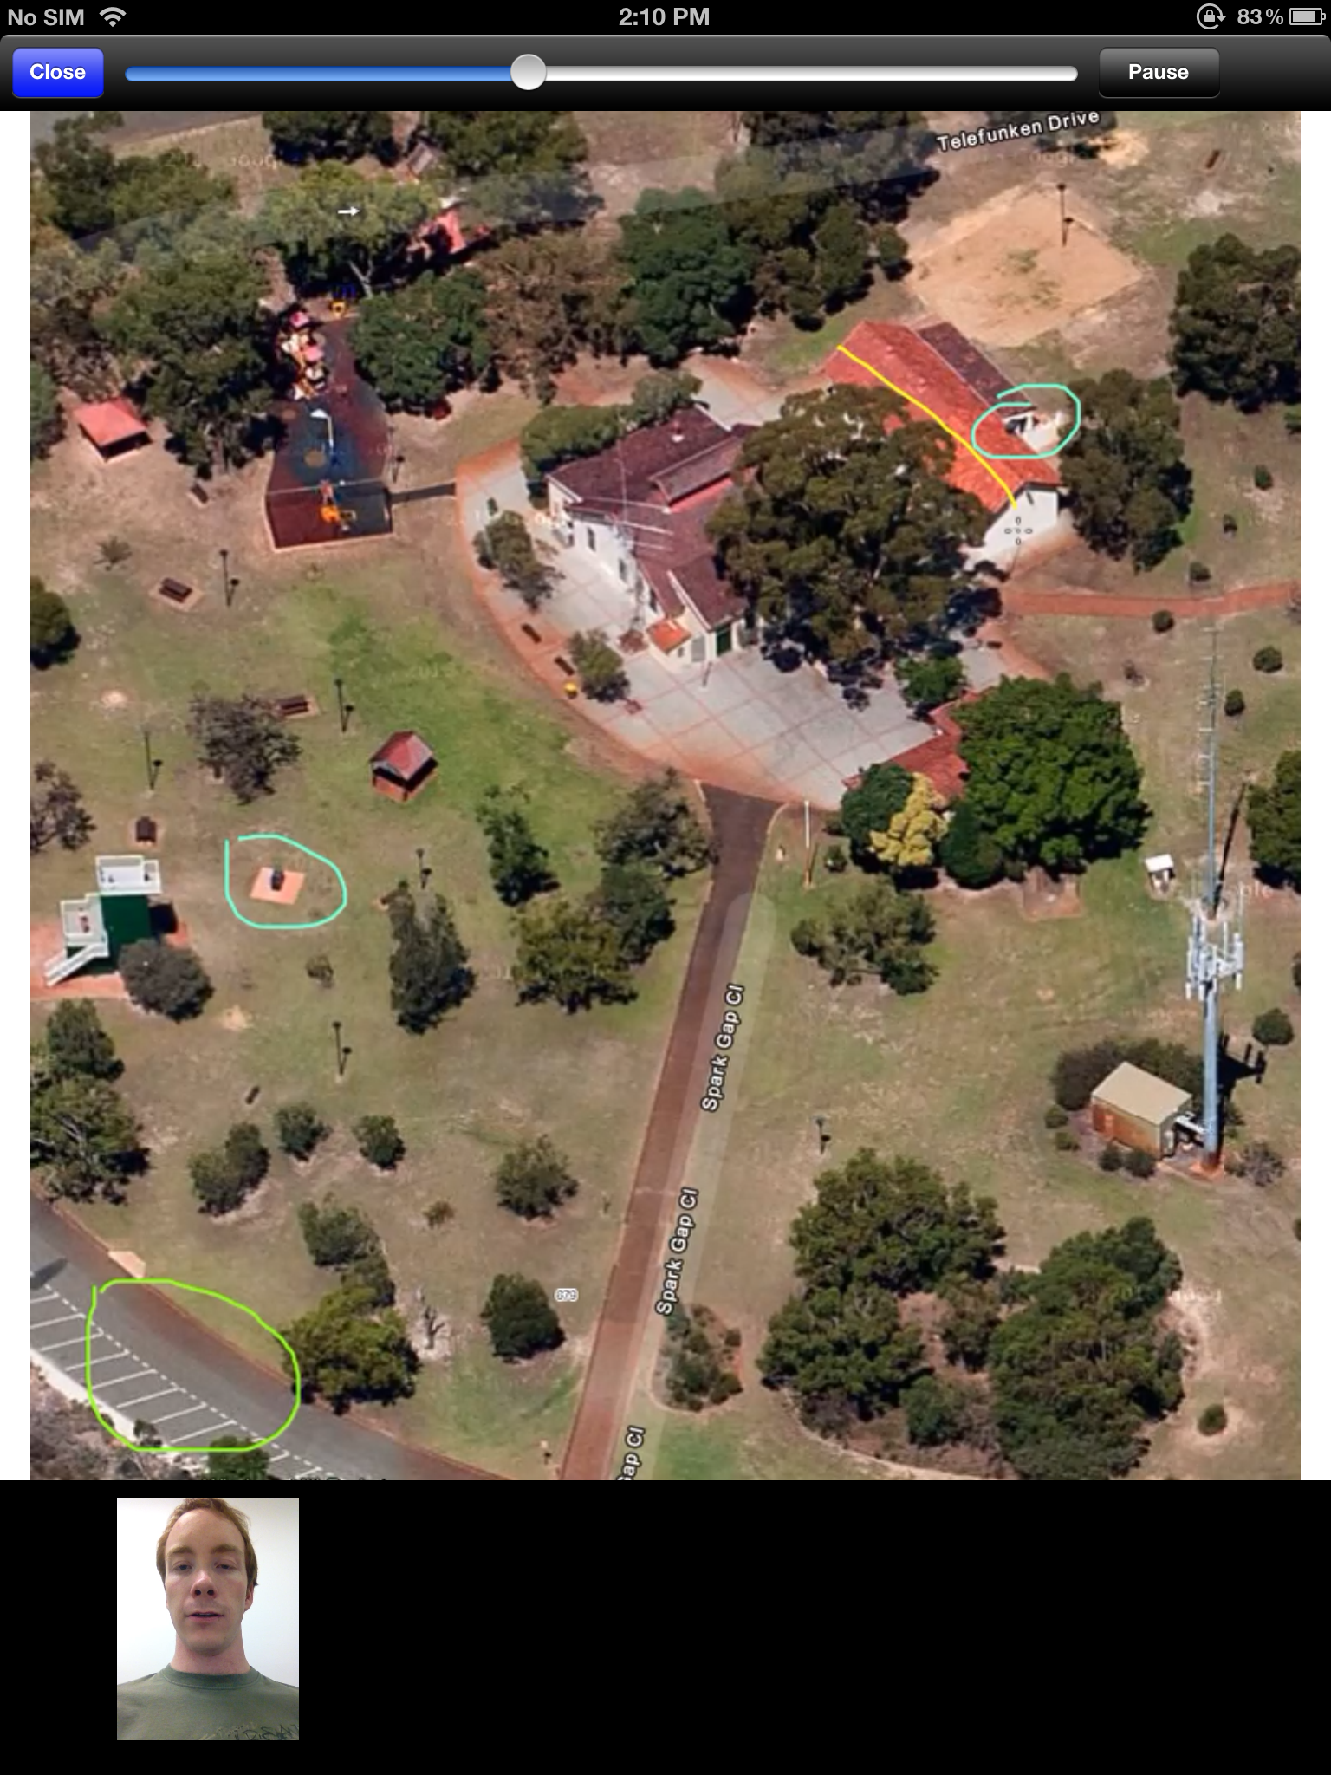

**Fig. 2.** Pre-recorded rich media annotation message

The questionnaire included six questions about participants’ experience with rich media recording and ten questions about real-time collaboration using ReColl. Fig 3 shows the specific aspects of the questions for rich media recording and Fig. 4 shows those for real-time collaboration. Participants rated the extent to which they agreed with the questionnaire statements based on a scale of 1 to 7, with 1 being “strongly disagree” and 7 being “strongly agree”.

RichMedia-Result.tif

**Fig. 3.** Average usability ratings for rich media recording mess

RealTimeCollaboratioon-result.tif

**Fig. 4.** Average usability ratings for real-time collaboration using ReColl

As shown in Fig. 3, participants felt that the rich media recording was an effective way of getting instructions. They also found that seeing a video of the instructor as they annotate the map was very useful. They would like to be able to reply to the message by doing their own annotations. The usefulness of the instructor’s face view and the feeling of engagement were rated as neutral and the scores were lower than the scores of the other aspects.

Participants were positive about the functionalities of the real-time collaboration in ReColl (Fig. 4). In particular, the usefulness of the annotation tool had the highest rating. Participants were satisfied with the ease of use, partner engagement and switching between different views while the sense of being together with remote partner was rated just neutral.

The preliminary prototype of ReColl used for the study allows participants to select either person view or document view to be displayed in full-mode by clicking on the thumbnails at the lower part of the iPad screen. We found that participants switched between different views depending on different interaction activities. During the first task most of the participants kept the map image as their primary view for full mode display. In the second task participants switched between different cameras and different views more frequently. Some of them switched to use the rear camera of iPad to show the objects on the table. Some of them took a photo of the objects on the table, shared the photo to their partners and drew on the photo to indicate objects of interest. They switched between the local workspace view and remote workspace view during the discussion. During the debrief sessions, some participants suggested a side-by-side view of the two workspaces and the ability to annotate on both views.

1. Discussion

Supporting both synchronous and asynchronous interactions in a hybrid way [1] has been one of the design considerations of ReColl. In particular, our solution of recording rich media annotation adds an additional level of rich information to support asynchronous communication. The use of rich media annotation has been tested in our pilot study which has shown positive results. Researchers have pointed out that hybrid telehealth and the approach of using video recording in consultation and reviewing video data at another time could be one of the future trends of telehealth [2]. Our research contributes to this field by exploring the design of integrating synchronous and asynchronous functionalities in mobile devices to support flexible and rich communications in healthcare delivery.

We are aware of the limitations of the pilot laboratory study. Although the study has received positive results, we plan to get feedback from actual users and investigate the tool in real healthcare setting. There is a need to understand how to support the integration of medical information sharing with video conferencing for different collaboration scenarios. The mobile collaboration tool can be considered as a complex interaction space that users may switch between or combine different views, such as live video conferencing between health workers and clinicians, interactive annotatable view of medical data and videos of patients. One of our future directions is the flexible configuration of this interaction space. We have also explored the security issues when using ReColl for collaborations [8].

We believe the design of ReColl provides us with an opportunity to further explore mobile solutions and new collaboration support of value to healthcare.

Reference

1. Pan, E., Cusack, C., Hook, J., Vincent, A., Kaelber, D.C., Bates, D.W. and Middleton, B. The value of provider-to-provider telehealth. Telemedicine and e-Health 14, 5, 446-53 (2008)
2. Yellowlees P, Nafiz N. The psychiatrist-patient relationship of the future: Anytime, anywhere? Harvard Rev Psychiatry; 18:96–102 (2010)
3. Tang, J., Marlow, J., Hoff, A., Roseway, A., Inkpen, K., Zhao, C. and Cao, X. Time travel proxy: using lightweight video recordings to create asynchronous, interactive meetings. In Proc. CHI2012, 3111-3120
4. Churchill, E.F. and Nelson, L. From media spaces to emplaced media: Digital poster boards and community connectedness. Media Space 20+ Years of Mediated Life, 57-73 (2009)
5. Fussell, S. R., Setlock, L. D., Yang, J., Ou, J., Mauer, E. and Kramer, A. D. I. Gestures over video streams to support remote collaboration on physical tasks. Human-Computer Interaction, 19: 273-309 (2004)
6. Alem, L. and Huang, W. Developing Mobile Remote Collaboration Systems for Industrial Use: Some Design Challenges. In Proc. Interact2011
7. Olwal, A., Frykholm, O., Groth, K. and Moll, J. Design and evaluation of interaction technology for medical team meetings. In Proc. Interact2011, 505-522
8. Jang-Jaccard, J., **Li, J.,** Nepal, S. & Alem, L. 2013, 'Security Analysis of Mobile-based Collaboration Tools in Health Applications', the 9th IEEE International Collaborative Computing: Networking, Applications and Worksharing (Collaboratecom)*,* Austin, Texas, USA, pp.553-562